Unsuitable plans for a Mega Prison at Full Sutton
Author Colin Clarke

Summary
The planned new large prison catering for 1440 inmates was promoted using unreliable information, claiming prisoners were allowed one visit per month when by law they are allowed 2 visits per 4 week period. Incorrect information regarding the proportion of trips by public transport was provided. The MoJ did not disclose a previous agreement to provide a public inquiry if a category C prison was being proposed for the site. Even with more than 1000 vehicle trips per day, that could result in more than 20,000 miles of driving, the planning process did not provide for an environmental impact assessment. East Yorkshire already has more than 1500 Category C prisoners, whereas North Yorkshire has none. Sir Greg Knight MP stated the October/November traffic surveys where not typical for the area. A review of the issues involved should be undertaken.
Background
Unsuitable plans for a Mega Prison at Full Sutton where given Outline planning approval in July 2017 for a 1017 capacity Category C prison and again in September 2019 for a 1440 capacity Category C prison on the same site, next to the existing maximum high security prison. Illustration of the prison and location details are shown below. Full planning permission may be considered shortly.
Size and scale
The proposed 1440 capacity Category C prison on a 52.9 acre site at Full Sutton will seriously impact on the area. Including the existing prison (about 580 inmates on a 50 acre site), there would be four times as many prisoners living in Full Sutton as there are villagers. It would dominate the village and Impact on its character and surrounding historic area.
Of the 17 buildings on the 52.9 acre site, six will be 4-storey accommodation X-blocks. These flood-lit buildings will be 14m (almost 46ft) high and clearly visible. Attempts to camouflage with trees will take years, especially with trees which lose their leaves in winter. The border fence would be very near to Moor Lane and add to the prison’s presence. The size and location would have a negative impact on the village and area.
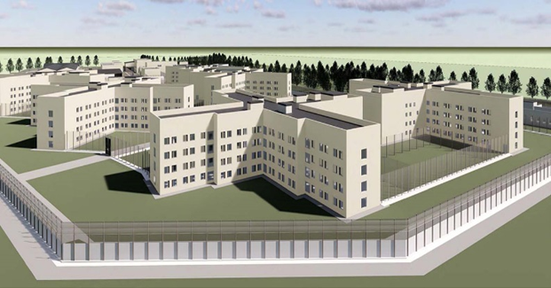
It would dominate the area in comparison to the existing low level two story maximum high security prison that is well set back from Moor Lane.
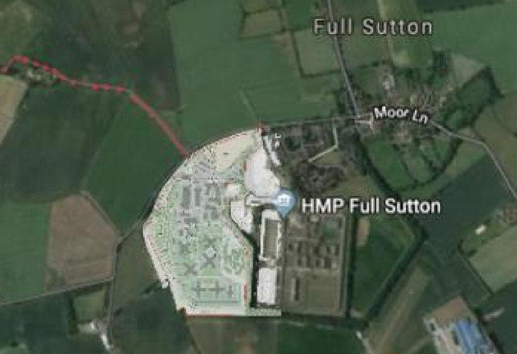
Full Sutton and its surroundings are an area of great natural beauty and close to the Wolds. The visual impact of this complex of high and ugly buildings towering over the rural community is going to impact on the enjoyment of tourists, visitors and the local inhabitants.
Transport issues
The prison with a planned 1440 inmates and 700+ plus staff would increase vehicle trips per day by more than 1000, adding to environmental damage and congestion across the road network and be harmful to National Cycle Network Route 66, Way of the Roses Cycle Route and the Minster Way long distance walking route together local conditions for cycling, walking, joggers and horse riders that use the minor roads of Moor Lane and Moor Road, (neither of which have pavements) on a daily basis.
A planning submission on behalf of Sustrans stated;
From a Sustrans perspective, this proposed development is unacceptable because:
(a) there are no proposals for creating new cycle/pedestrian routes between the site and Stamford Bridge, and other nearby villages;
(b) no thought has been given to the impact of all the extra traffic on the safety of existing cyclists using National Route 66 | Way of the Roses and other rural roads in the area;
(c) none of the roads giving access to the site, from whatever direction, have any existing safety provision for pedestrians or cyclists, and there is no proposal to provide any.
The TA fails to fully consider the negative consequences.
With the already serious queuing problems in Stamford Bridge, some traffic tends to use the roads via Buttercrambe as a “rat run” to avoid the delays. Details from Buttercrambe and Bossall Parish Council and the Catton Parish Council mentions the problems. The proposed prison would increase the problem. The Transport Assessment provided had serious flaws and misleading information and did not provide an Environmental Impact Assessment to properly quantify the consequences of the transport and sewage issues that Stamford Bridge Parish Council raised concerns about. The TA fails to consider that about 90% of prison journeys could be by car, increasing greenhouse gas emissions. The location would result in building in long term greenhouse emissions for staff and visitors. Alternatives sites near to motorways or regular bus/rail services would be more suitable and should be considered.
Area consequences
Stamford Bridge is best known for its battle of 1066 and the history resulting in William the Conquer successfully invading the country. The minimum distance from the prison to the Battlefield is approximately 1.2km (3/4 of a mile). The 6 four storey building would be in view from the Battlefield and have some impact on the Battlefield setting or focusing attention on the area being closely associated with prisons. The registered Stamford Bridge Battlefield is shown below. Visitors to the Battlefield will most likely use Moor Road. The Battlefield landscape is basically farmland with isolated buildings.
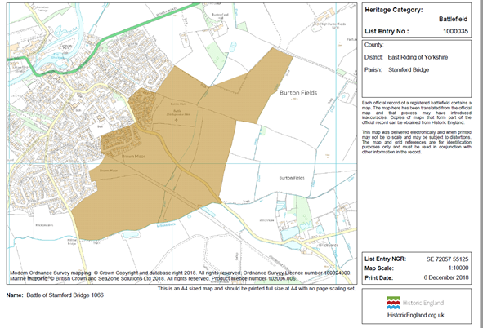
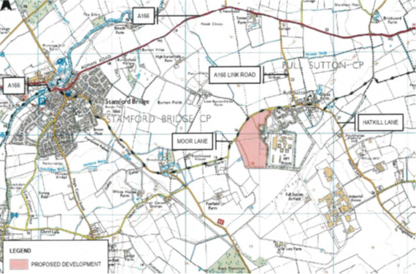
Howard League for Penal Reform comments
Frances Crook, Howard League for Penal Reform, stated:
‘This prison is not needed. There are already 4,000 category C prison places in the area (Holme House, Wealston, Lindholme and Humber prisons).’
and
‘This prison would be a huge waste of public money, would fail victims of crime as the majority of prisoners commit more crimes on release and would have a deleterious impact on the local community.’
Currently, drug use in the area is low, but day release of prisoners nearing the end of their sentences could encourage drug dealers into the area. BerwynCategory C prison, (UK’s newest and largest prison, HMP Berwynhas considerable drug problems. - HMP Berwyn: Drugs 'readily available' at Wrexham prison - BBC News 2018). Two prisons together at Full Sutton with about 2000 inmates may be a prime target for the drug dealers to set up in nearby locations. Dealers may also promote their products to nearby population. Drug dealing in Wrexham has been reported to be a serious issue. Frances Crook, Howard League of Penal Reform submission states:
‘The government recently built a huge Cat C prison in Wrexham which is causing problems for the local area with an average of 13 ambulance call outs a month.’
Drug offences accounted for 2.7% of all crime recorded by the police in the year ending March 2017 for England and Wales^{[1]}. In comparison the nearby towns of Pocklington and Market Weighton have less than 1%^{[2]}. Building a large Cat C prison at Full Sutton could result in increasing drug problems in the area that is currently at low levels.
Ref HMP Berwyn: Drugs 'readily available' at Wrexham prison, 13 July 2018 https://www.bbc.co.uk/news/uk-wales-north-east-wales-44818506
[1] https://www.ons.gov.uk/aboutus/transparencyandgovernance/freedomofinformationfoi/drugoffences2017
[2] Pocklington and Market Weight crime prevention group data.
Statement by local MP (pdf available on request)
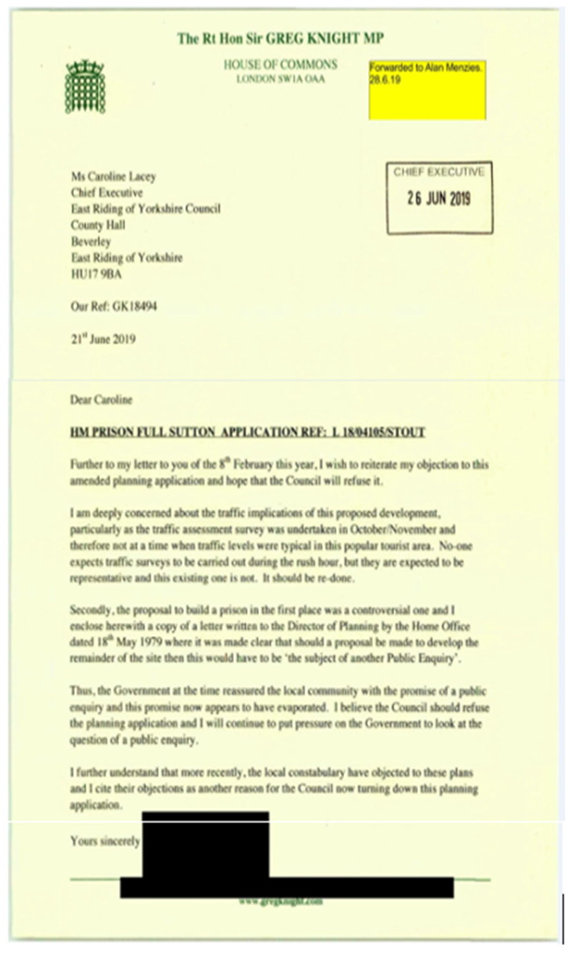
East Yorkshire already has enough prisons
East Yorkshire, with a population of approximately 600,000 people, currently has three prisons, Full Sutton, Hull, and Humber, an average of about one prison per 200,000 people, a rate of approximately 5 per million population. For England and Wales with a population of about 59.5 million there approximately 118 prisons, an approximate rate of 2.0 per million population. East Yorkshire has already more than double the rate of prisons in proportion to population, 5.0 v 2.0. The extra prison proposed would result in the East Riding having a rate of 6.7 per million population v 2.0 for England and Wales. For Wales the rate is less than 2 prisons per million population. Yorkshire has 14 prisons and about 5 million population, already exceeding the national average with a rate of 2.8 per million population.
The East Riding already has category C prisoners at Hull and Humber prisons. North Yorkshire only has one male prison HM Prison Kirklevington Grange category D 283 capacity with no provision for category C prisoners.
Estimated number of existing Category C prisoners in Yorkshire
 | Current Cat C prisoners | Population - millions | Rate per million population | If new prison is added at Full Sutton,  (extra 1440) | Rate per million population
ERY | 1550 | 0.60 | 2580 | 2990 | 4980
NY | 0 | 0.60 | 0 | 0 | 0
SY | 2440 | 1.4 | 1740 | 2440 | 1740
WY | 1490 | 2.3 | 648 | 1490 | 648
ERY – East Riding of Yorkshire, NY- North Yorkshire, SY-South Yorkshire, WY- West Yorkshire
The East Riding does not need a mega prison, it has enough prisons already.
Police objection details
The police objected to the planning application for various reasons including;
Increased Reported and Recorded Crime
a) Comparisons with similar sized category B prisons to that proposed in the planning application show recorded criminal offences to be circa 250 per year, the majority of which (circa 150) are recorded violence offences.
b) These offences require investigation which will place significant additional demand on Humberside Police.
Local Community Impact
a) There will undoubtedly be a significant increase in the volume of people travelling to and from the proposed prison. It can be anticipated this will lead to additional incidents and crime being reported to police impacting on the local community.
b) This increased demand is likely to draw police resources from other areas of the East Riding and impact on response times for emergency calls for service in rural areas.
The police had serious concerns about the overall implications for the area and it would be better to consider alternative locations for a major new prison. Even if more police are provided the area could still be affected.
Increased risk
Prisons are getting larger and the information indicates that with larger prisons there is an increased risk of injury, death and other problems. The number dying in prisons has increased from approximately 150 in 2000 to 320 in 2018. Similarly, the number of assaults has increased to more than 20,000. Effects on prisoner welfare is not a ‘material consideration’ in the planning process. Local Councillors in general have not the background to assess prisoner welfare aspects in relation to prison size and location.
https://www.theguardian.com/society/2019/jan/31/prison-figures-reveal-rise-in-deaths-assaults-and-self-harm
Main failings
The planning process resulted in failures in several ways, some are listed below.
1
The Ministry of Justice did not disclose in either outline planning applications details of a prior agreement concerning the site as mentioned in Sir Greg Knights letter. The Home Office stated in writing that “any proposal to develop the remainder of the site as a Category C prison would have to be the subject of another public inquiry”. This was a solemn undertaking from Government to residents. It should be honoured. With a major prison development affecting an whole area it needed a public inquiry to allow public involvement and for individuals and groups to speak directly to an independent planning inspector and to be able to question claims made.
Protesters in Stamford Bridge
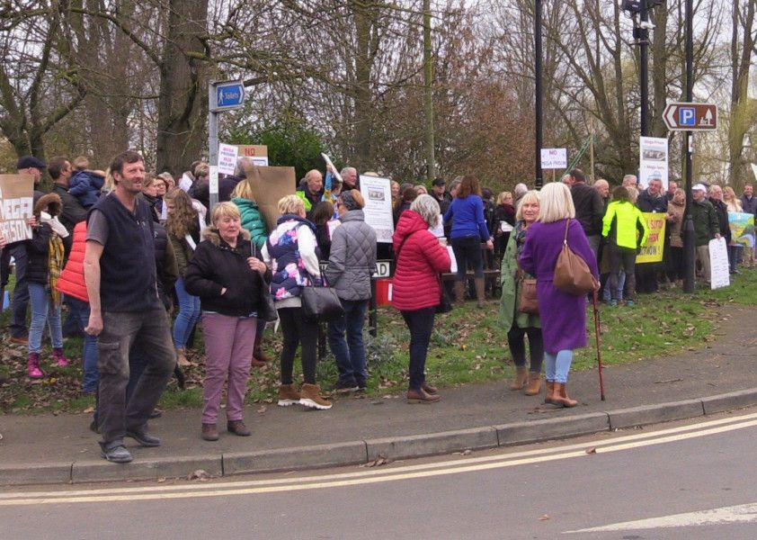
https://www.yorkshirepost.co.uk/news/crime/full-sutton-prison-campaigners-find-1979-papers-showing-government-promised-pubilc-inquiry-1755747
https://www.bbc.co.uk/news/uk-england-humber-47427283
2
The public consultations did not allow sufficient time to properly distribute information to residents.
FULL_SUTTON_AND_SKIRPENBECK_PARISH_COUNCIL-2678456
submission 15 June 2017 state;
Public Consultation
We are very concerned about the community consultation undertaken. The efforts to engage and communicate with the community to gauge their views and opinions on the development have been inadequate. A good example, is the public engagement event. This was poorly advertised in the local and wider community, meaning that many residents were not aware that it was taking place. The inadequacy of the consultation process means that the views and opinions of the community are not being adequately considered and represented.
3
The MOJ used unreliable claims to gain planning approval. As examples, they stated prisoners were allowed one visit per month, when legally they are allowed two visits per four week period. They claimed 40% of visitors would use public transport, that has now been acknowledged to be incorrect. These claims helped the previous application, for a 1017 inmate prison to be approved at the outline planning process. They assumed that visitors may come three-to-a-car, but doesn't consider the effect if they come with two or one in each car. Weekend traffic conditions were not assessed in either application, when visitor to the East Riding can be at higher levels. Sir Greg Knight MP correctly stated the October/November traffic surveys where not typical for the area.
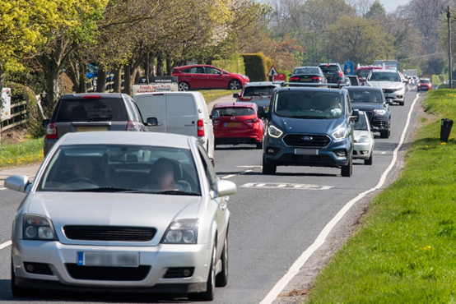
The 2018 application with 1440 prisoner v previously 1017 prisoners, 41% extra prisoners. In both forecasts the single lane bridge would exceed capacity. No account was taken of emergency vehicles being delayed. The Yorkshire Ambulance Services submissions especially mentions their concerns.
In summary we do not object providing adequate mitigation is in place around traffic in Stamford Bridge and internal processes are implemented at the new prison to minimise calls to Yorkshire Ambulance Service.
Note; no provisions have been made to provide adequate mitigation in Stamford Bridge.
The site selection of Full Sutton for an additional large Category C prison, near to Stamford Bridge and the ‘East Riding of Yorkshire Council, Local Transport Plan, Strategy 2015 – 2029’, page 43 states;
Stamford Bridge
7.2.26. The A166 between York and Driffield is constructed to single carriageway standard and is around 7.3 metres wide on average. However, the grade II* listed bridge in the centre of Stamford Bridge only allows for single file traffic in each direction, managed by traffic signal control. This forms a sub-standard section of the route which leads to delays and localised congestion at peak times.
The MoJ Traffic Assessment (TA) provided by Atkins shows there would be about 31,800 trips per month and assumes 35% of prison traffic will go via Stamford Bridge. The Local Transport Plan referring to Stamford Bridge and the A166 states; ‘This forms a sub-standard section of the route which leads to delays and localised congestion at peak times. The MoJ failed to disclose this part of the route is considered a sub-standard section of the highway. It was essential that the traffic assessment needed to reflect typical or normal traffic condition. October was selected for the traffic surveys. On balance, October tending to reflect lower than average for the A166 due to the time of year and lower trip numbers to the seaside in general and Blackpool illuminations being a major attraction in October for the Yorkshire region. The number of seaside trips in England and Wales are approximately half from October to March compared with April to September. Overnight trips to the seaside comprise about 24% of trips from October to March v 76% from April to September2. The A166 is the shortest route from the Leeds area to the coast at Bridlington. October is normally considered a ‘neutral’ month for traffic assessments but for the A166 it would have lower traffic levels than normal and not be typical. The MoJ/ERYC allowed the October survey to be used knowing traffic levels would very likely be lower than normal/typical for the A166. The other usual ‘neutral’ months are late March; April; May, June, September and November. November and late March may incur about half the seaside trip rate and would be expected to be below normal. April; May, June or September would have been more suitable to assess the traffic levels. The TA failed to provide reliable survey data to reflect normal traffic conditions, as Sir Greg Knight refers to. There was also a dispute on the time period that reflected the PM peak period.
Pell Frischmann Traffic Assessment (TA) (PF - ERYC Consulting Engineers) audit state;
3.10 Section 3.4.2 states that the AM and PM peak hours on the local highway network are 07:30 – 08:30 and 17:00 – 18:00 respectively. A Pell Frischmann review of the raw turning count data has indicated that the stated PM peak hour is incorrect, with the actual network peak hour occurring between 16:30 and 17:30.
The data by the MoJ (Atkins) used the period 17.00 to 18.00 as the peak PM period to reflect prison traffic.
The traffic data shows PCU (passenger car unit) values for the A166 bridge in Stamford Bridge to be;
16.30 to 17.30 = 1212.7
17.00 to 18.00 = 1082.5
The added traffic from the prison on the bridge is forecast to be 35% of 161 and 35% of 197, mainly 56 and 69 for each hour period.
Therefore, traffic in total crossing the bridge would equate to;
16.30 to 17.30 = 1212.7 + 56 = 1268.7
17.00 to 18.00 = 1082.5 + 69 = 1151.5
Traffic levels would be 10.2% higher in the 16.30 to 17.30 period compared to the 17.00 to 18.00 period and therefore would have been appropriate to detail fully in the TA.
4
There are also concerns with the ERYC proceedings with an initial letter of support for using the site without consulting the local councils in the area. In the planning meeting the Chair’s comments (Cllr McMasters) stated
‘the sewage and security and congestion are all relative to local people living in the area, they really are, and if I was living in the area they would be to me too as well, however they not matters for us today, they are not matters concerning, they are matters for building regulations. Regards congestion, Highway England will need to do something to get involved with this’.
Neither the A166 nor the A1079 are included in Highway England responsibilities, therefore the statement was invalid and the committee and both security and congestion are matters requiring serious consideration that should not have been dismissed. The Chair also focused attention on possible proceeding that may follow if the application was refused. These could have been more inconvenient for the ERYC and detracted from considering the merits of the application and basing the planning decision solely on the merits of the application.
5
Proper consideration of the distribution of category C prisons in the Yorkshire region was not provided.
6
One of the 12 core principles of England’s National Planning Framework (NPPF) states that planning should: “actively manage patterns of growth to make the fullest possible use of public transport, walking and cycling, and focus significant development in locations which are or can be made sustainable.” (NPPF Section 17).
Nearly all trips to the prison would be by motor vehicle and very few by public transport, walking and cycling. The site is not a sustainable site and would increase traffic, congestion and emissions.
The prison plans do not provide an environmental impact assessment, potentially a major failing.
Proposed action
1
Alternative plans should be provided to remove the need for a large category C prison at Full Sutton.
2
The site could be kept for any extension to the existing high security prison that may be needed or for a reduced scale of prison.
3
A Public Inquiry should consider the issues because the Home Office in 1979 agreed if a proposal to develop the remainder of the site was made then this would have to be 'the subject of another Public Inquiry'.
4
A revision of the National Planning Policy Framework and Planning law so that it gives equal rights of appeal for proposers and objectors in the planning process for major developments.
5
A review of the plans is needed and direct discussions with local councils.
REASONS
Currently, the planning procedures permit applicants the right to appeal against refusal, they have three options, Written, Hearing or Inquiry, however objectors are permitted to object but no right of appeal.
A major prison development at Full Sutton in East Yorkshire was granted outline planning permission without undertaking an environmental impact assessment. If built, it will result in deterioration in conditions for both walking and cycling in the surrounding area due to the extra 1000 plus motor vehicle trips per day.
In the example of Full Sutton, parts the NCN route 66 is close by and used by prison staff, thus adding more traffic. Sustrans objected along with about 3000 other objections. All the local councils objected along with the police and Sir Greg Knight MP. Misleading information was published in support of the application. There is no right of appeal by a third party, i.e. objectors. If ERYC refused permission, an appeal could be lodged potentially costing ERYC in legal expenses. A right of appeal by objectors is needed to help protect the public from unsuitable major plans.

