January 2015

Dear Fangfoss, Bolton & Spittal villagers,
Best wishes for 2015 from the volunteers that run Jubilee Park.
It is now some 12 years since the idea was mooted to develop a Park for the village. At the time eight people set up a committee to look at how a Park might be established after a local landowner had agreed to lease 9 acres of fairly rough land close to the villages. It was felt that this would be the only opportunity available for such a development. Previously it had been hoped to establish a cricket field and £20k was held at the bank for such a purpose. The committee involved in that venture agreed to donate the money to help start the Park.
Since then as you will know land was flattened, paths laid, tress planted, areas fenced off, drains laid, a dog walking area created and then play equipment introduced over a period until this year when a zip wire was built and swing nest installed. All in all including annual maintenance costs over £240,000 has been spent to create and maintain the Park we see today. Apart from the initial £20k, the bulk of the money has been raised via Lottery Funding and WREN (Waste Reclamation Environmental). Our own fundraising efforts have contributed over £50k and we have had smaller amounts from local charities, the Parish Council and individuals.
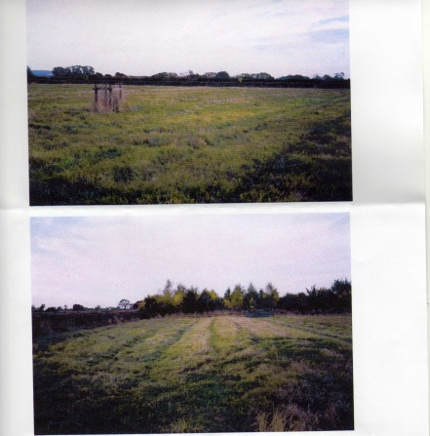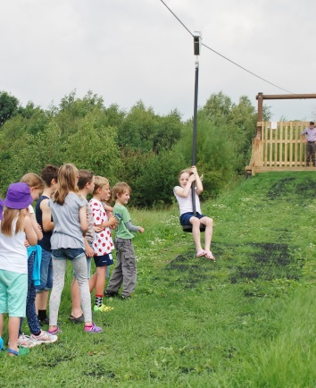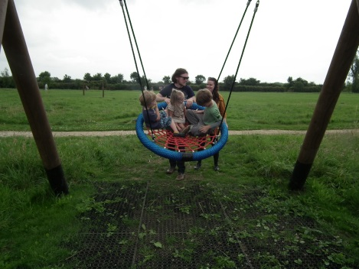
In the beginning – 2004 At the opening of the zip-wire and swing nest 2014
We now have a Park we can all be proud of, which is run by many of the original volunteers plus a number of new people from the village who have joined over the years. We are set up as a public company with audited accounts which have to be sent to Companies House on an annual basis. This and the week to week management of the Park is all done by volunteers and we should welcome anyone else who is willing to offer assistance. We especially need younger volunteers to look to the future running of the Park as a large proportion of our committee are “getting on a bit”.
The Park is an asset the village can be proud of and according to a survey published 14th November 2014 headlined “The growing love affair with a Park” – “a patch of green could be worth more to the value of your home than a decent high street, or even a good local school”. The report went on to state that parks and gardens can affect property prices more than any other amenity.
Please support the Park whether or not you use it, it appears it could affect the price of your house!
One way of supporting the Park is to become an annual or life member – membership costs £5 per person per year. As a member you are entitled to vote at the AGM and attend monthly committee meetings. You will also be invited to our free annual supporters’ social event.
2015 events planned for the Park at present are as follows – we hope to see you and rely on your support.
21st Feb St Crux
March Potato competition sales
14th March Family Disco
20th June Safari Supper
16th Sept Potato competition awards
7th Nov Bonfire Night
TBA Race night

See any committee member for tickets and information or membership:
Lyn Grant Chair
Ann Maltby Vice Chair
Elizabeth Macpherson Secretary
Jo Hamilton Treasurer
Committee Members: Gerry Grant, Richard Allen, Bob Broughton, David Nelson, Bob Holley, Corrado Topi, Dave Nichol, Danielle Davy

Thank you for your support over the years and looking forward to many more successful Park events.

Lyn Grant
Chair

